**LECTURE 3**

**USE CASE DIAGRAMS**

**FIRST ELEMENTS OF A USE CASE DIAGRAM**

Use case diagrams have two useful properties

1. They show the things of interest to us
2. They show how these things are related

**PARTS OF THE MODEL:USE CASES**

**PARTS OF THE MODEL:ACTORS**

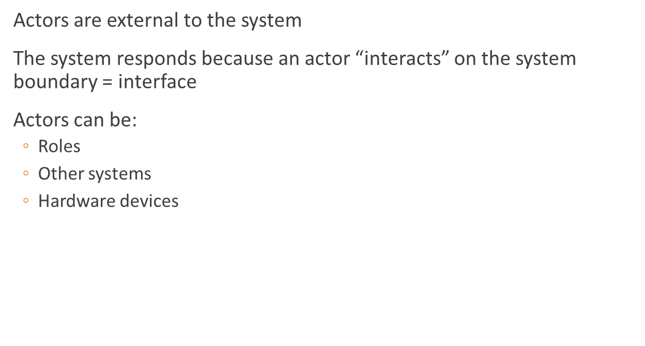

**RELATIONSHIPS: CONNECTING THINGS TOGETHER**

Association (between use cases and actors)

Include (between use cases)

Extend (between use cases)

Generalization (between use cases or between actors)

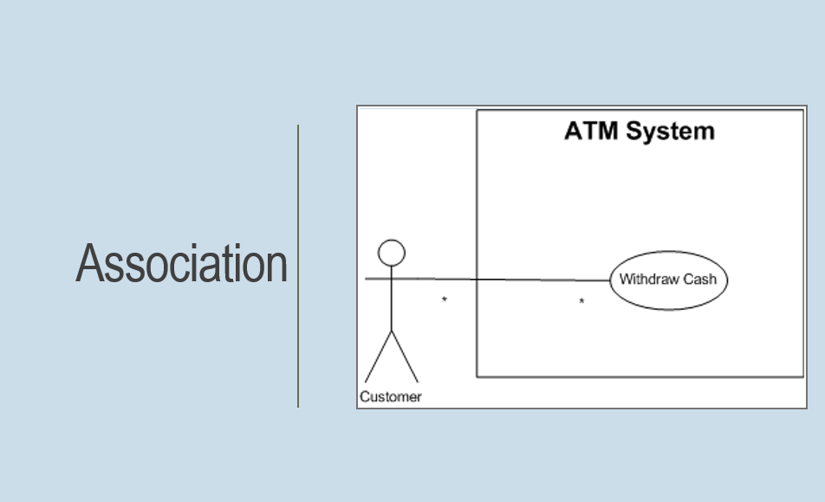

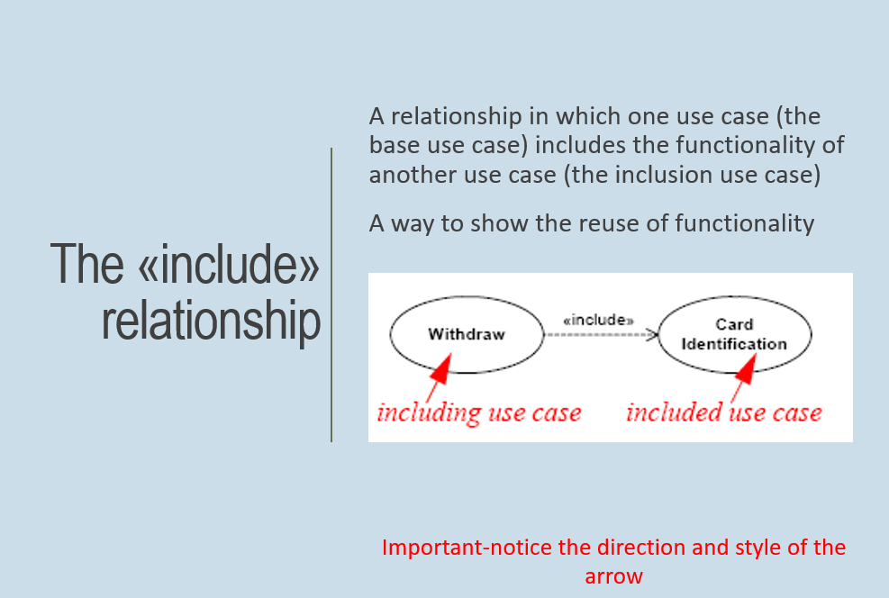

Shows the dependency between the base use case and the included use case. Every time the base use case which means the including use case is executed the included use case is executed as well.

Also the base use case requires and included use case for the order to be complete.

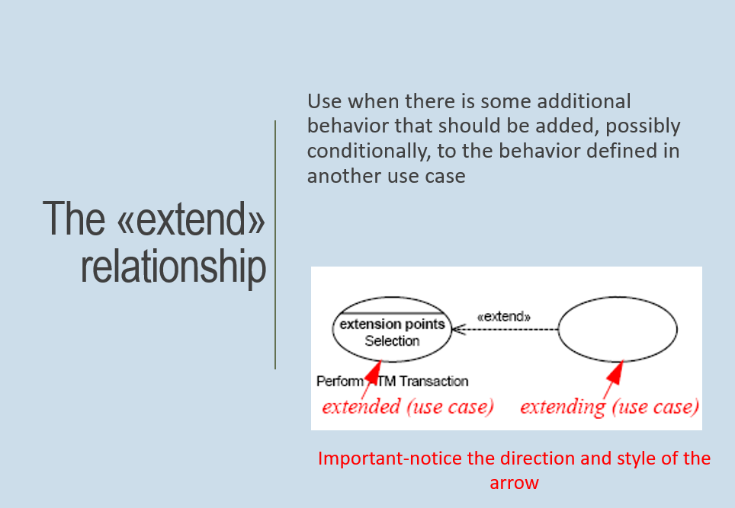

An extend relationship has a base use case and an extend use case. When the base case is executed, the extend use case will happen sometimes but not every time. The extend use case will only happen if certain criteria are met. Also the option to extend the behavior of the base.

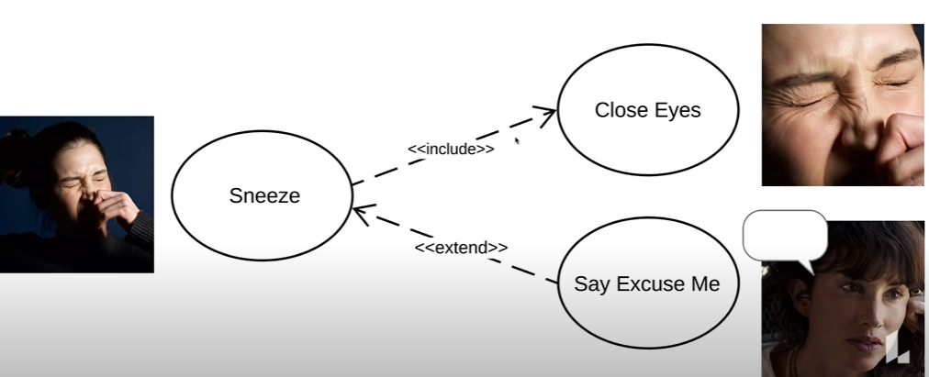

**EXTENSION POINTS**

An extension point is the point in a use case where another use case, which extends the functionality of the first use case, may or may not occur, depending on some condition.

An example might be the use case for paying for an item, which has an extension point at the payment type

Extending use cases may then extend at this point to pay by direct debit or credit card



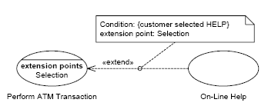

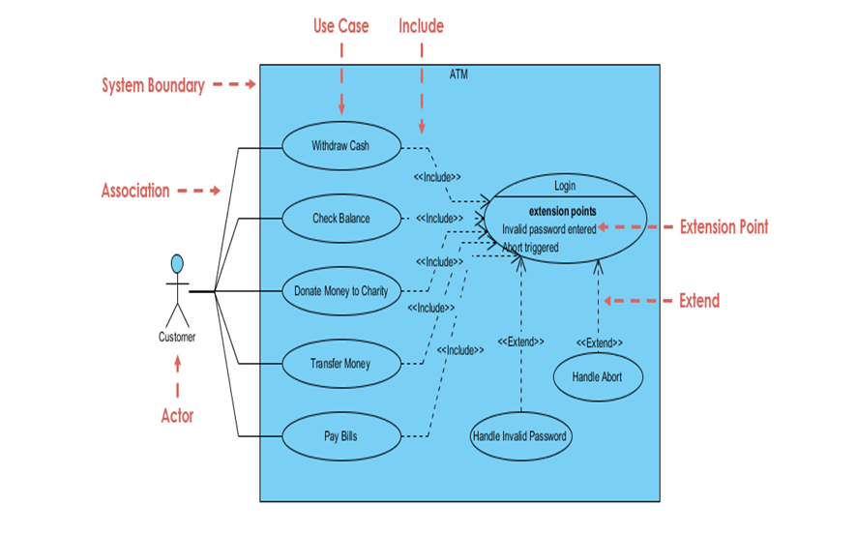

**GENERALIZATION**

A generalization relationship is one in which one model element (the child) is based on another model element (the parent)

The child receives all of the attributes, operations, and relationships that are defined in the parent

Note: We can generalize actors or use cases

